# Module 8 – Internet forums



## Module 8 objectives

At the end of this module, you will be able to…

* talk about Internet forums and online bulletin boards.
* use computer terminology.
* investigate and present facts as a result of your research.
* use special vocabulary related to forums.
* form questions in English.
* identify and answer Java-related trouble-shooting questions.
* talk about how Internet forums are structured.
* talk about the features of an Internet forum.
* write a summary of information from a text.
* talk about the importance of having rules on a forum.
* write rules for participating in a forum.
* use the modal auxiliary verbs *must* and *should* to express obligation.

And you will know…

* why Internet forums are useful for Java programmers.
* where to ask for help from your professional community.
* why asking for help when you need it is important for getting things done.

**Lesson 1 – What is a forum?**



## Lesson 1 objectives

At the end of this lesson, you will be able to…

* talk about Internet forums and online bulletin boards.
* use computer terminology.
* investigate and present facts as a result of your research.

And you will know…

* why Internet forums are useful for Java programmers.
* when to ask for help from a professional community.

## Activate

Discuss with a partner. Share your answers with the rest of the class.

* Do you use Internet forums?
* Why are forums useful?

## Learn

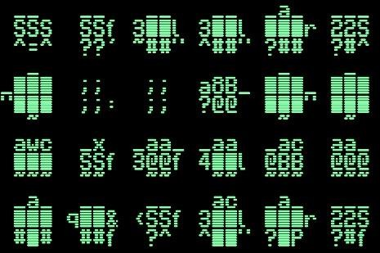

1. Listen to the podcast. What is the podcast about?

1. Listen to the audio again. Work with a partner. Read the following statements. Are they **true** or **false**? Correct the sentences that are false.

* 1. Forums are a brand-new idea.
  2. Forums are based on an idea from the 1970s.
  3. Bulletin boards worked because of data transferred over phone lines.
  4. Communication on bulletin boards was in real time.
  5. You could play games on bulletin boards.
  6. Forums have more functions than bulletin boards.
  7. Java programmers use forums to solve their programming problems.

Check your answers by reading audio script 8.1.

1. Work with a partner. Read audio script 8.1 and underline as many examples of words and phrases related to computers as you can find. Look at the examples underlined in red.

1. Work with a partner. Use an online dictionary to find out the meaning of the words that are new for you. Share what you discover with the rest of the class.

## Do

1. Work individually. In your portfolio, write sentences using the words and phrases you learned in Activity 4. Try to make the sentences true for you. Share your sentences with your classmates.

**Let’s use it!**

1. Work in groups of three. Investigate online to find out more about bulletin boards from the 1980s and 1990s. Write what you discover in your portfolio.

1. Prepare a PowerPoint presentation with what you found out in your investigation in Activity 6. Record voice narration for it. Be sure to use some of the computer language you learned in Activities 4 and 5. Upload your presentation onto the class Wiki. Vote for the best presentation. Justify your vote.

**How did I do? Evaluate yourself.**

|  |  |  |  |  |
| --- | --- | --- | --- | --- |
|  | **I can’t yet…** ☹ | **More or less (-)** | **Yes, I can!** 😊 | **If you need help, go to…** |
| I can talk about Internet forums and online bulletin boards. |  |  |  | Activate and Activity 1 |
| I know why  Internet forums are useful for Java programmers. |  |  |  | Activity 1 |
| I can use computer terminology. |  |  |  | Activities 4 & 5 |
| I can investigate and present facts as a result of my research. |  |  |  | Activities 6 & 7 |
| I know where to ask for help from my professional community. |  |  |  | I can communicate! |

**I am professional!**

**Being part of a professional community**

Part of being a professional is working as part of a larger community. When you form part of a community, you can ask for help when you need it, learn from others and support your colleagues.

Work with a partner. Investigate online to find out what professional communities exist for Java programmers. Write what you find out in your portfolios.

# Lesson 2 – The language of forums



## Lesson 2 objectives

At the end of this lesson, you will be able to…

• use special vocabulary related to forums.

* form questions in English.
* identify and answer Java-related questions.

And you will know…

* why asking for help when you need it is important for getting things done.

## Activate

Discuss with a partner. Share your answers with the rest of the class.

* Do you know any of the special vocabulary for talking about forums? (User, or message, for example.)
* How did you learn this language?

## Learn



1. Work with a partner. Listen to the podcast. What is it about?

1. Work with a partner. Listen to the podcast again and answer the following questions according to what you hear.

* 1. A thread is…
     1. something we use to make clothes.
     2. also known as a topic.
     3. an idea.
     4. an argument.

* 1. When a thread is stickyed…
     1. it is given more importance than other threads.
     2. it gets stuck.
     3. it is blocked.
     4. it has a lot of users participating in it.

1. Trolls are…
   * 1. mythical animals.
     2. very ugly.
     3. users who deliberately post comments that annoy other users.
     4. users who block other users.

1. Feeding the troll means...
   * 1. giving the troll food.
     2. ignoring the troll.
     3. encouraging the troll.
     4. asking the troll questions.

1. A flame war is when…
   * 1. users do not post anything useful in the forum.
     2. users argue on the forum.
     3. users set each other on fire.
     4. users waste forum space arguing about topics that are not important.

1. A sock puppet is…
   * 1. a puppet sold online.
     2. the multiple accounts a user may have within a forum.
     3. the multiple accounts of one user which interact with each other within a forum.
     4. a piece of clothing.

1. Work with a partner. In the podcast Joe mentions question forms. What do you know about forming questions in English? Complete these rules with a partner.

* 1. We move an ______ verb to the front of the sentence and we put a question _______ at the end of the sentence.

She **is** playing football.

**Is** she playing football?

The house **has** been painted.

**Has** the house been painted?

* 1. We move a _______ auxiliary verb to the front of the sentence and we put a question _______ at the end of the sentence.

I **can** play the piano.

**Can** I play the piano?

He **will** help you.

**Will** he help you?

* 1. For sentences in present simple or past simple, we add _____ or _____ for the present or ______ for the past to the beginning of the sentence and a question _______ to the end of the sentence.

Maria live**s** in Sao Paulo.

**Does** Maria live in Sao Paulo?

Everybody **went** to the party?

**Did** everybody go to the party?

1. Work with a partner. Write comprehension questions to test another pair on the information in the podcast. When you have finished, test each other.

## Do

1. Complete the following sentences so that they are **true** for you.

* 1. I can ___________________________________________________
  2. I love ___________________________________________________
  3. I might __________________________________________________
  4. Yesterday, I went _________________________________________
  5. I am ____________________________________________________

1. Play a guessing game in pairs. Try to guess your partner’s sentences. You can only answer yes or no.

Student A: Can you play football?

Student B: No, I can’t.

Student A: Ok, can you play the piano?

Student B: Yes, I can!

**Let’s use it!**

1. Work with a partner. Visit a forum for Java programmers. Identify three questions frequently asked by programmers using the forum. Write them on a piece of paper.

1. Do the questions you identified on the forum follow the grammar rules in Activity 3? Why/why not? Decide with your partner. Compare your answers as a class.

1. Give the questions you wrote in Activity 7 to another pair. Ask them to investigate online to find the answers to the questions.



**How did I do? Evaluate yourself.**

|  |  |  |  |  |
| --- | --- | --- | --- | --- |
|  | **I can’t yet…** ☹ | **More or less (-)** | **Yes, I can!** 😊 | **If you need help, go to…** |
| I can use special vocabulary related to forums. |  |  |  | Activities 1 & 2 |
| I can form questions in English. |  |  |  | Activities 3, 4, 5, 6 & 8 |
| I can identify and answer Javarelated questions. |  |  |  | Activities 7 & 9 |
| I know why asking for help when I need it is important for getting things done. |  |  |  | I am competent! |

|  |
| --- |
| **I am competent!**  **Asking for help** Asking for help is a key strategy for achieving your goals. Sometimes we don’t want to ask for help when we have a problem, or when we need to achieve something. This reluctance to ask for help prevents us from getting things done.    Work with a partner. Answer the questions.   * Why do people find it difficult to ask for help? * In what ways does asking for help get us closer to achieving our goals? * How is the idea of asking for help related to the topic of Internet forums?     Post your ideas onto the class Wiki. |

# Lesson 3 – How forums are structured and how to use them effectively

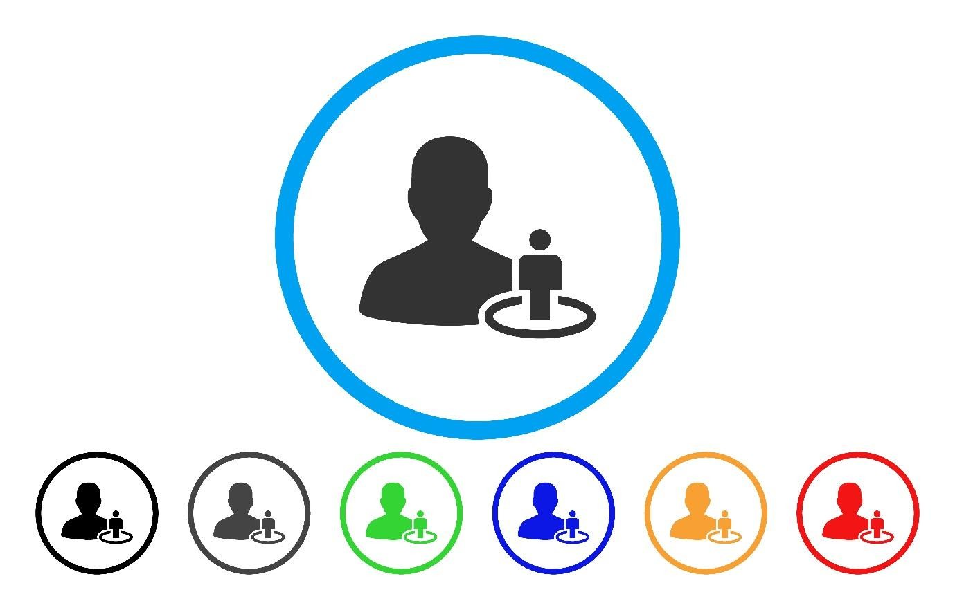

## Lesson 3 objectives

At the end of this lesson, you will be able to…

* talk about how Internet forums are structured.
* talk about the features of an Internet forum.
* write a summary of information from a text.

## Activate

Work with a partner. Discuss the following questions.

* How is an Internet forum structured?
* What functions or features does an Internet forum have?

## Learn

1. Work with a partner. Read the Web page to check your answers to the questions in the Activate section.

|  |
| --- |
| [www.forumforme.com/forumstructure](http://www.forumforme.com/forumstructure) |
| Internet forums or message boards are structured in a certain way and there are certain functions you need to understand in order to use them effectively.    Forums have a hierarchical directory structure. At the top of the hierarchy come the categories. These are the general areas of interest. Then under each category, we find sub-forums, followed by more sub-forums. In the sub-forums, you find the topics or threads. There are three basic display formats: non-threaded, semi-threaded and fullythreaded. The non-threaded format is used when the messages are not related to each other. The semi-threaded format is used when a post has multiple replies. And the fullythreaded format is used when a post has replies and replies to replies.    The discussions in the threads are driven by users known as members. These members can be visitors or logged-in members. The members are governed by users known as moderators. Moderators organize users into user groups. The moderators give rights and permissions to users based on the user group they belong to. Administrators manage the technical aspects of the forum and promote members to moderators.    Useful functions of a forum are private messages, attachments, polls, and ignore lists. Private messages can be sent from one member to another or from a member to multiple members. There is a blank copy (BCC) function, so sometimes members are not aware of whom has been sent to. Attachments are files that you attach to your post. Forums normally limit the size of the file due to server space. Forums have a polling system with multiple choice questions so that members can vote on a particular issue. The voting can be anonymous or public. Results polls are displayed graphically. Sometimes members will want to hide from other members or not see their posts in order to avoid problems. To do this, they will put them on their ignore list.    On this page, we have seen the most important information about how Internet forums are structured and the most important features they have. We also touched on the different roles members can assume on a forum and how they are managed. |

1. Work with a partner. Read the Web page again. Decide if the following statements are true, partly true or false. Use the information in the Web page to make the partly true and false statements true.

* 1. Forums are organized hierarchically.
  2. In the hierarchy, sub-forums are more important than categories.
  3. The fully-threaded display format is used when a post has replies.
  4. Moderators give rights to the administrators to manage the technical aspects of the forum.
  5. Attachments are files you attach to your private messages.
  6. With a poll you can vote for your favorite member.
  7. You put your favorite members on your ignore list.

1. Work with a partner. Read the text again. Look at the words underlined in red. Categorize them in the graphic organizer.

Forums

Structure

People

Functions

## Do

1. Work with a partner. Visit an Internet forum. Identify the vocabulary in your graphic organizer in Activity 3. Compare your answers as a class.

**Let’s use it!**

1. Work in pairs. Write a 150-word summary of the information on the Web page in Activity 1. Read the information in the I can communicate box before you begin. Make sure to use the vocabulary you learned in Activity 3.

1. When you have written your summary, upload it onto the class Wiki. Read your classmates’ summaries. Edit them to correct mistakes and improve content.

**I can communicate!**

**Writing a summary**

Work with a partner. Order the step in the process of writing a summary then use the process to write a summary in Activity 5.

Write a first draft of your summary using your notes _____

Write a second draft of your summary _____

Publish your summary _____

Don’t include any examples or evidence in your notes about each paragraph _____

Read the text to fully understand the main idea of the author __1__

Read your first draft and make sure it is coherent (well-organized), include any missing connecting words and phrases _____

Correct spelling and grammatical mistakes in the second draft _____

Express the author’s main idea in writing (20 words approximately) _____

Read the text again and make notes about the important points in each paragraph _____

**How did I do? Evaluate yourself.**

|  |  |  |  |  |
| --- | --- | --- | --- | --- |
|  | **I can’t yet…** ☹ | **More or less (-)** | **Yes, I can!** 😊 | **If you need help, go to…** |
| I can talk about how Internet forums are structured. |  |  |  | Activate,  Activities 1, 2,  3 & 4 |
| I can talk about the features of an Internet forum. |  |  |  | Activate,  Activities 1, 2,  3 & 4 |
| I can write a summary of information from a text. |  |  |  | Activities 5 & 6, I can communicate! |

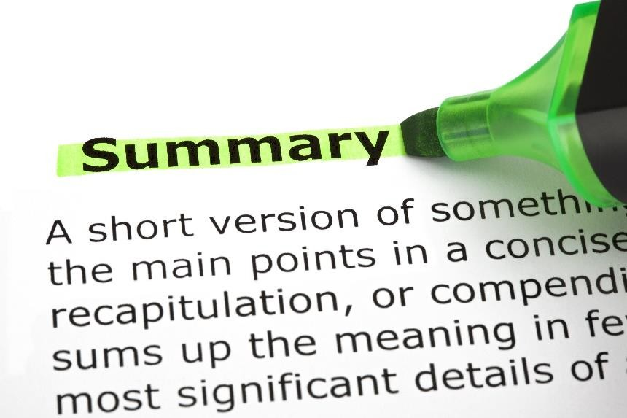

# Lesson 4 – How to behave on a forum



## Lesson 4 objectives

At the end of this lesson, you will be able to…

* talk about the importance of having rules on a forum.
* write rules for participating in a forum.
* use the modal auxiliary verbs *must* and *should* to express obligation.

## Activate

Discuss the following questions with a partner.

* What are the rules for participating on a forum?
* Why is it important to have rules for a forum?

## Learn

1. Work with a partner. Read the Web page to check your answers to the questions in the Activate section.

|  |
| --- |
| [www.forumforme.com/netiquette](http://www.forumforme.com/netiquette) |
| There are certain rules for how to behave on an Internet forum. These rules are called netiquette. They can normally be found in the FAQ (Frequently Asked Questions) section. Netiquette is enforced by the forum moderators. Members can report misbehavior to the moderators via private message. The Initial consequence for bad behavior will be a private message sent by a moderator to the offending party to explain to them how they have broken the rules and to ask them to stop. If the member does not stop their behavior, they are usually banned from the forum for a few days. If they then persist, they will be banned for a longer period of time. Repeated misbehavior normally results in a permanent ban for that member. If they open another account and continue to post offensive content or not follow the netiquette of the forum, their IP address will be banned. Threads with offensive content are usually deleted or blocked so that no one can post on them. Common breaches of netiquette are trolling, where a member posts offensive or irrelevant content onto the forum, or spamming where some form of advertising is posted. Spamming can also be malicious, with the member posting the same word over and over again.    In terms of good behavior, members are expected to treat other members with respect. They should understand that people often have different views or values and that they should respect this. The use of emoticons can help communication, as they add a degree of emotion to what the member is posting. Emoticons can, for example, can communicate friendliness. Avatars are a good way pf personalizing your message, as other members can see what you look like and/or learn something about your personality. Signatures added at the end of your posts also give your content a more personal touch.    Forum owner have to be careful of legal problems. It is important that the content on a forum not be interpreted as libelous of defamatory. So, any content that is offensive should be deleted immediately. Also, any content that belongs to someone else (the PDF of a book, for example), should not be shared as this content needs to be paid for and the forum may be sued under copyright law. Often, a judge will rule that it is the member who posted the content who is responsible. However, the owners of the forum will have to spend money and time defending themselves against lawsuits like these, so it is best to avoid them from the beginning.    On this page, we have seen how members should behave on a forum and the possible consequences of their not doing so. We also mentioned the legal issues surrounding owning or managing a forum. |

1. Work with a partner. Read the Web page again. Decide which of the following statements are true and which are false. Correct the false ones.

* 1. Rules on an Internet forum are called netiquette.
  2. Forum administrators enforce netiquette.
  3. Members of a forum not following netiquette are immediately banned from the forum.
  4. Members should treat other members with respect.
  5. Members should expect other members to have the same ideas as they do.
  6. It is not a good idea to personalize your communication on a forum.
  7. Forum owners can face legal problems if they are not careful about how they manage their forum.

1. Work with a partner. Complete the following sentences to make a list of rules for participating in a forum based on the information in the text. Compare your answers as a class.

* 1. Members must ______________________________________

* 1. Members should ____________________________________

* 1. Moderators should __________________________________

* 1. Forum owners must _________________________________

1. Work with a partner to complete the grammar rules for how we use the modal verbs *should* and *must*. Compare your answers as a class.

* 1. We use the modal verb _______ to express strong obligation.
  2. We use the modal verb _______ to express a personal opinion.
  3. In the sentence “I must to arrive on time”, the word _____ is incorrect.

## Do

1. Decide whether the following sentences are true for you. Correct the sentences that are false to make them true. Use the information in the I can communicate box to help you.

* 1. I must get more exercise.
  2. I should go to the dentist more often.
  3. I mustn’t smoke.
  4. I should eat more healthily.

**Let’s use it!**

1. Work with a partner. Visit a Java programmers forum. Look at the way they interact. Are they following netiquette? Why/why not?

1. In your pairs, write pieces of advice for them on the class Wiki. What modal verb are you going to use to give advice *must* or *should*?

1. Vote as a class for the best pieces of advice. Justify your votes.

|  |
| --- |
| **I can communicate!**  **Expressing obligation in negative sentences**    The negative of should is **shouldn’t**.  I **shouldn’t** eat so much sugar.    The negative of must is **don’t have to** if we are talking about something which is optional.  You **don’t have to** wear a tie to work if you don’t want.    The negative of must is **mustn’t** if we are talking about something we must not do.  I **mustn’t** be late for class.    Work with a partner. Decide which of the following sentences are correct and which are wrong.     1. You mustn’t be disrespectful of other members on a forum. 2. You don’t have to be disrespectful of other members on a forum.      1. You don’t have to use emoticons. 2. You mustn’t use emoticons. |

**How did I do? Evaluate yourself.**

|  |  |  |  |  |
| --- | --- | --- | --- | --- |
|  | **I can’t yet…** ☹ | **More or less (-)** | **Yes, I can!** 😊 | **If you need help, go to…** |
| I can talk about the importance of having rules on a forum. |  |  |  | Activate,  Activities 1 & 2 |
| I can write rules for participating in a forum. |  |  |  | Activity 3 |
| I can use the modal auxiliary verbs *must* and *should* to express obligation. |  |  |  | Activities 4, 5, 6, 7 & 8 |

# Lesson 5 Product lesson

In this module, we have talked about different aspects of forums. You are now going to work in a group of three to find the most useful forum for Java programmers in your opinion.

Before you do this, discuss the following question in your group.

**Why are forums useful for Java programmers?**



When you have finished discussing, compare your answers as a class.

In your group of three, visit some of the forums that exist for Java programmers. Participate on these forums and decide which is the best in your opinion. Be prepared to justify your opinion. Make a video presentation of the forum you discovered. Explain why this forum is the best option. Include screen shots or real-time interaction on the forum.

**I can learn**

**!**

What did you learn from this lesson?

Write your ideas in your portfolio. Compare what you write with a partner. Discuss

what you

read in each other’s portfolios.



## Evaluate the product lesson

|  |  |  |  |  |
| --- | --- | --- | --- | --- |
|  | **Could be better** ☹ | **More or less**  **(-)** | **Yes, we did it!**  😊 | **What we can do next time to improve** |
| My partners and I worked well as a team. |  |  |  |  |
| Our product was interesting for the rest of the class. |  |  |  |  |
| We learned something that we can apply to our real lives. |  |  |  |  |
| We were able to reflect on what happened during the class. |  |  |  |  |

**Audio scripts**

[Audio script 8.1]

Tom: So, hi everyone and welcome to our podcast on what’s new in technology. Today, our topic is actually on something not so new: Internet forums. And something that is definitely not new: bulletin boards. So, Joe, tell us a little bit about what a forum is and what it’s used for.

Joe: Well, Tom, a forum is a web application with user-generated content. The idea is based on the old bulletin board system.

Tom: I remember bulletin boards! They date back to the 1970s, but I used to use them in the 1980s and 1990s to share ideas and have conversations with people who were into the same stuff. You used to dial up using a modem which would connect your computer to a phone line. Then you could choose a bulletin board to enter with a password. Once you were in the bulletin board, you chose a conversation. These conversations weren’t in real time. You entered the bulletin board and read the messages that were there, typed your message and then logged off. You had to wait - sometimes weeks - for someone else to post a reply to your message. There were also games you could play and newsletters. There was very little color on the interface. The text was in ASCII format, so there were no fonts and the graphics were very basic. So, tell us about forums, Joe.

Joe: Well, forums are a very similar idea to the old bulletin boards. But there are more tools, such as opinion polls, and the interaction is in real time. They are sometimes called message boards. They are spaces where like-minded people share information and have conversations in the form of posted messages. They are different from chat rooms in that the text is longer than one line and it is archived. Messages posted may also need to be approved by a moderator before they appear on the forum. Users of the forum can be anonymous, or they may have to log in in order to post.

Tom: And what kind of forums are out there, Joe?

Joe: Well, basically there are forums for everything. For our listeners the most interesting types of forums are those for programmers. There are lots of forums where Java programmers exchange tips on how to deal with problems that they face in their daily work. This is an enormous community of programmers helping each other out.

Tom: Well, thanks for that, Joe! Stay tuned folks for more info on what’s new in technology.

[Audio script 8.2]

Tom: Hey, everyone! Welcome back to our podcast on what’s new in technology. I’m here again with Joe and today we’re going to continue on the topic of forums that we were looking at last week. Today, Joe is going to explain to us a little bit about the language used by participants in forums.

Joe: Hi, Tom! Hello, everyone. Yes, it’s really interesting. The language used by the people participating in forums is a special kind of language.

Tom: What do you mean by a special kind of language?

Joe: Well, to start with the vocabulary used is different. This special vocabulary is called jargon. There is a special jargon for Internet forums.

Tom: Such as?

Joe: Well, for example, a conversation or discussion on a forum is known as a thread or topic.

Tom: Ok, anything else?

Joe: Well, when a thread is important it is stickyed or pinned. This means that the thread is displayed before a normal thread. And there are lots of other words we should know if we’re going to use Internet forums. Trolls, for example, are users who post inflammatory or offtopic comments with the deliberate intention of annoying or provoking a reaction from other users. Users are discouraged from replying to a troll. When you reply to a troll, this is called, “feeding the troll”. If you feed a troll, a flame war can occur. A flame war is when the users don’t actually discuss anything useful on the forum and just spend their time attacking each other.

Tom: Interesting, is there anything else we should know?

Joe: Well, a term I found really funny was sock puppet.

Tom: Sock puppet?

Joe: Yes, sock puppet. A sock puppet is a user who opens more than one account and the two accounts from the same user post comments, normally agreeing with each other. In this way, the user is a puppeteer controlling their sock puppet. Sock puppets can be identified when an IP address check is done on the users in the forum. When this is done, you can see repeated users.

Tom: Are there any other aspects of language that forum users should be aware of?

Joe: Yes, question forms are common, especially on forums for Java users, because they normally post a question about a problem they have. On Java forums, grammatical items such as the present continuous or present perfect are common, because the users talk about something they are doing or something they have done, which has produced certain results. And finally, of course, on forums you find very specialist language. On Java forums, you find a lot of Java programming language and terms, such as bootstrap/jquery, css properties, or returning a function.

Tom: Well, thanks for that Joe. Stay tuned everyone for our next exciting podcast!